PROJECT CREATION USING SERVLETS:

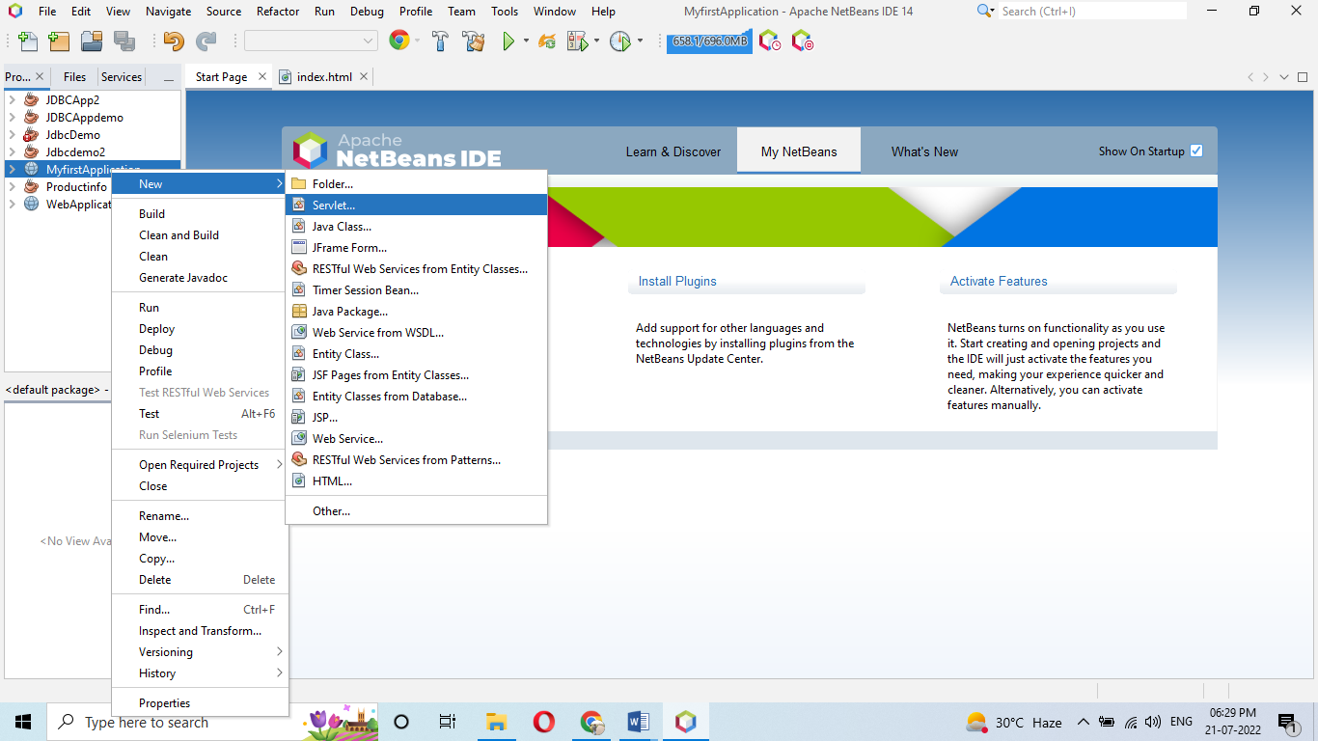

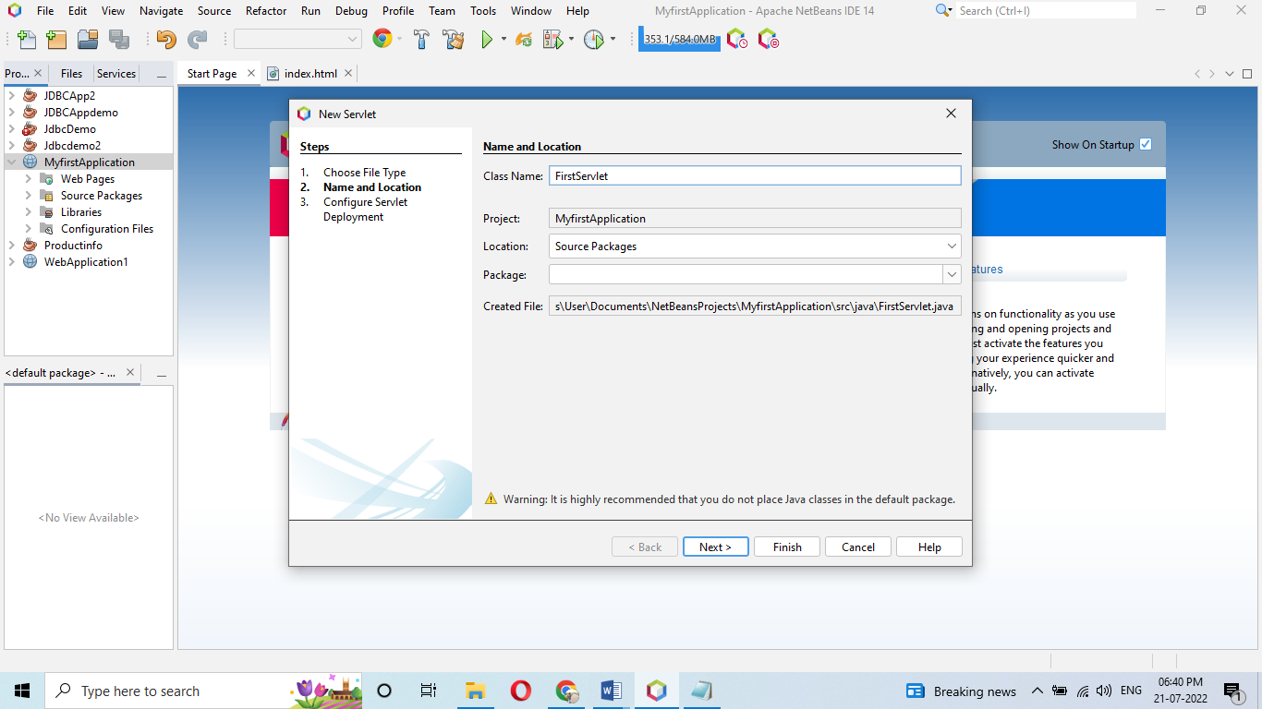

NEXT

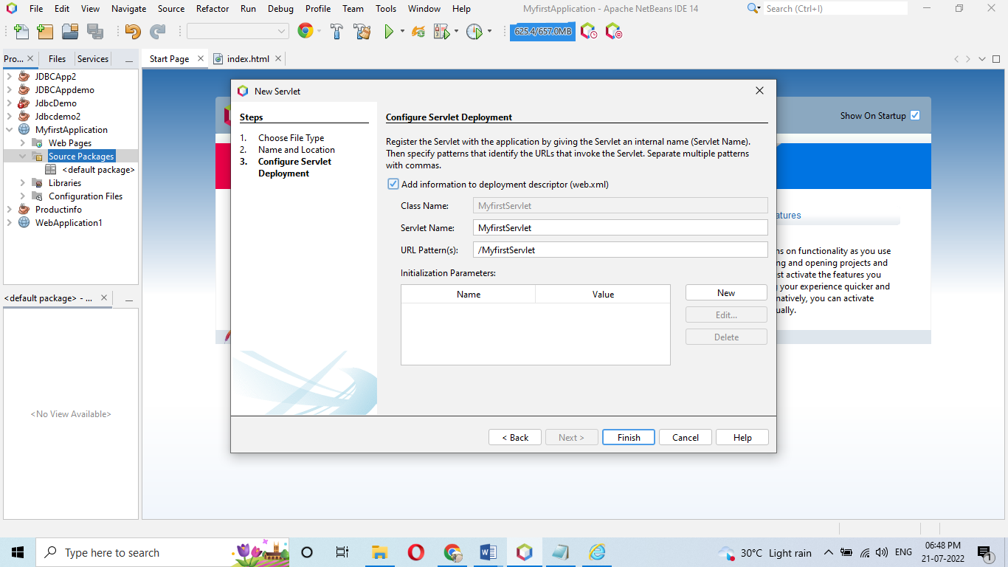

CLICK CHECKBOX TO ADD DEPLOYMENT DESCRIPTOR.XML FILE

FINISH

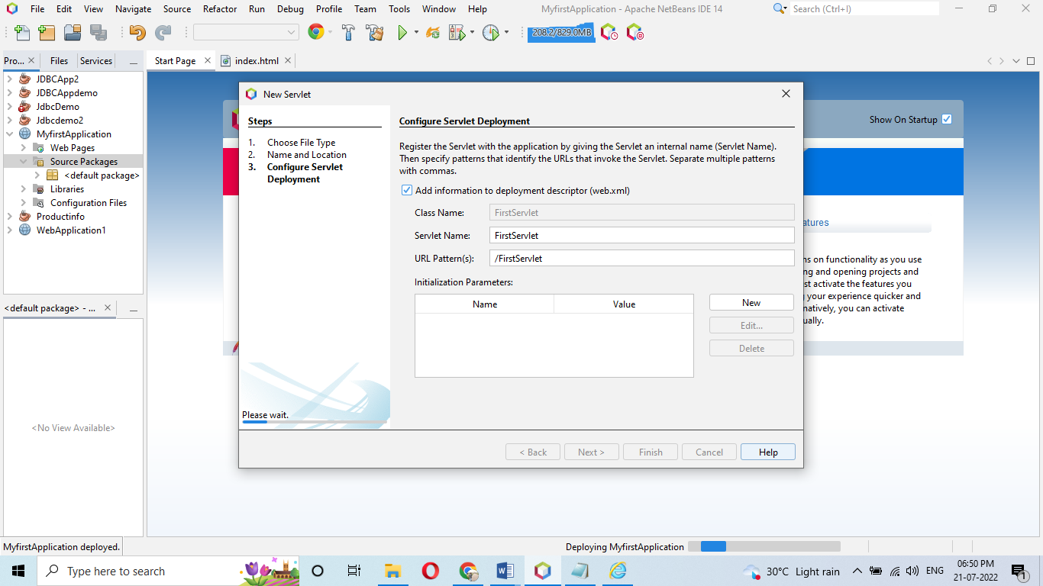

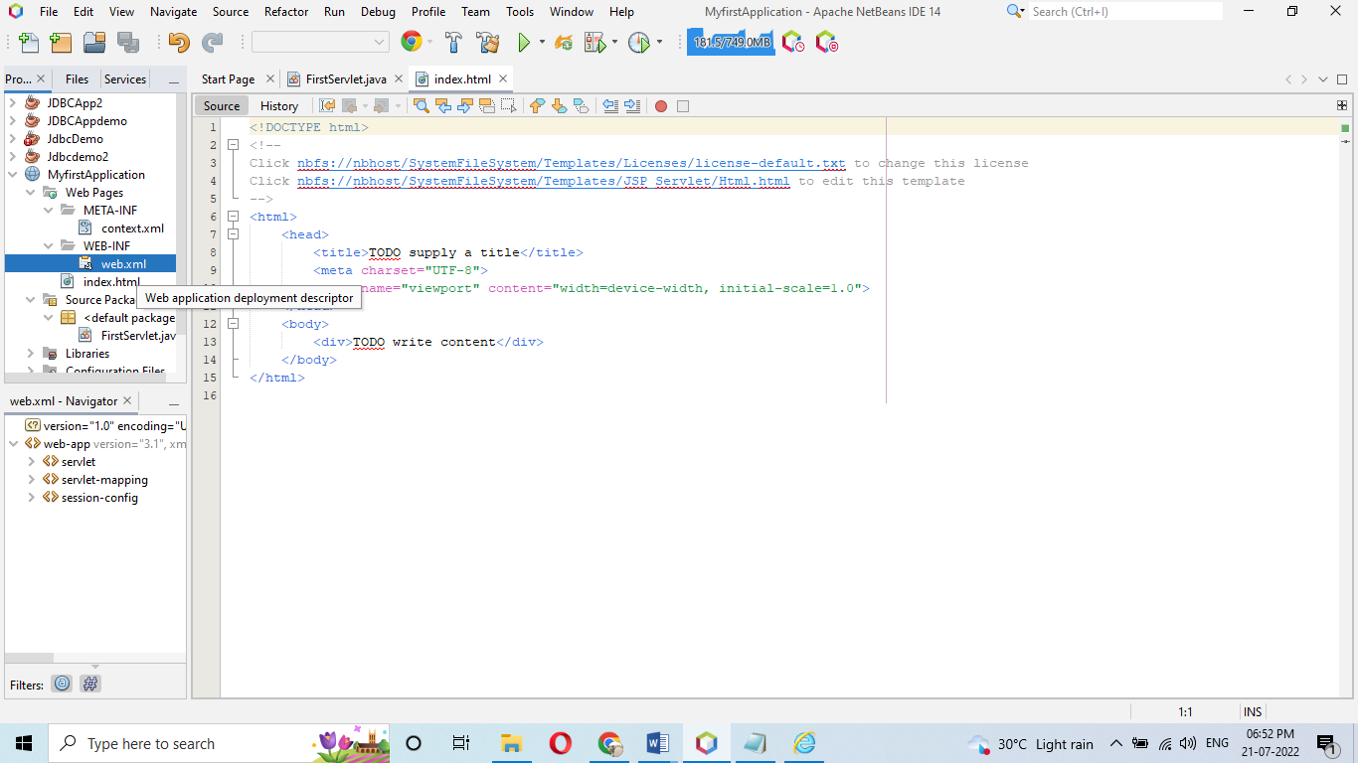

DEFAULT PAGE:

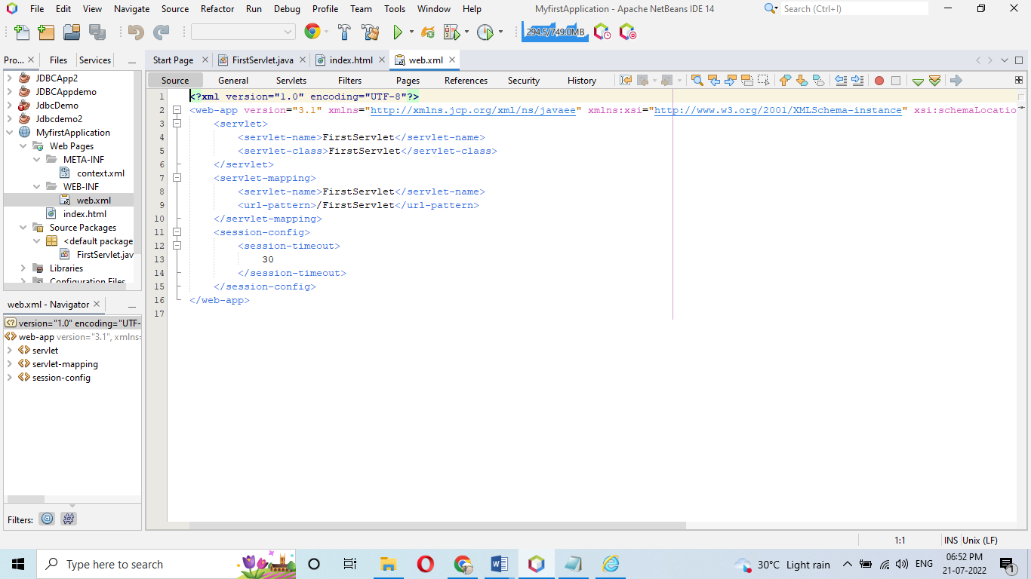

CHANGE URL AND SERVLET NAME:

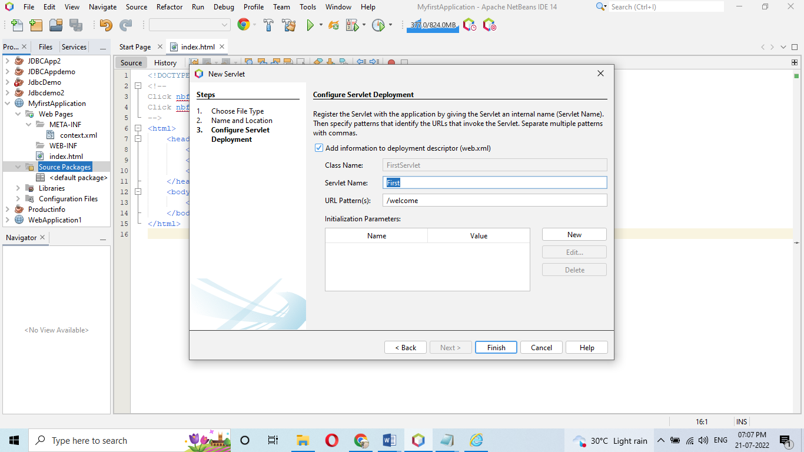

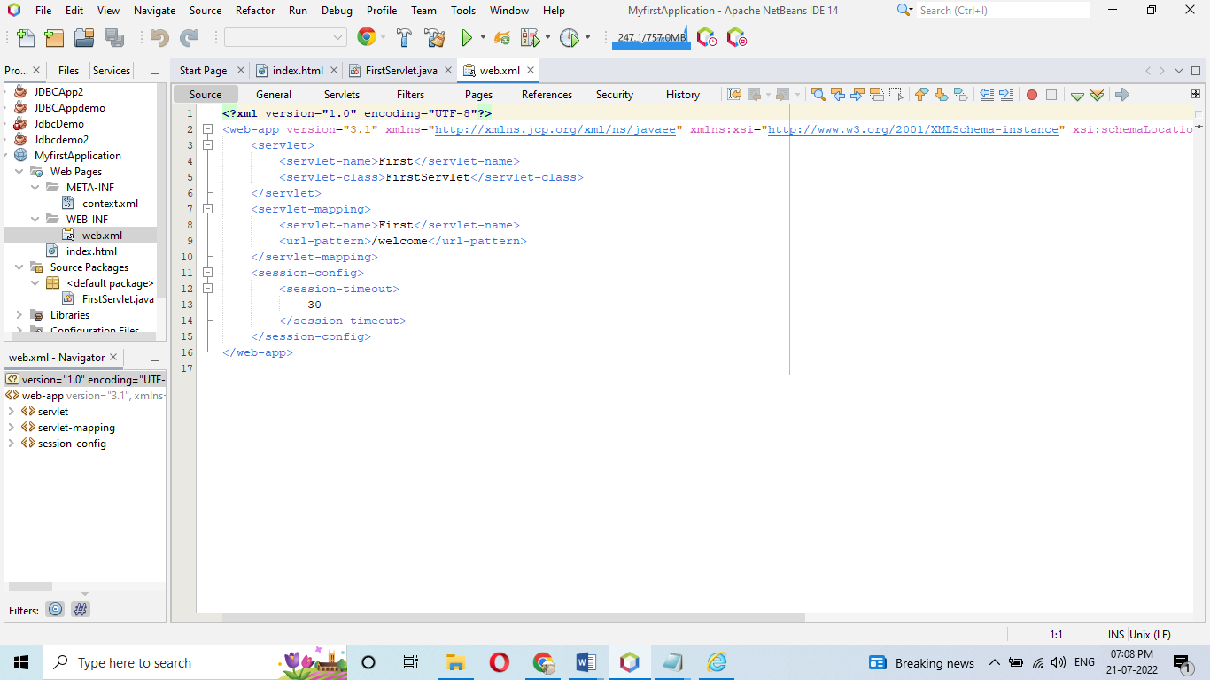

CREATING APPLICATION PAGES:

STEP 1:

CREATE SERVLET WITH WEB.XML

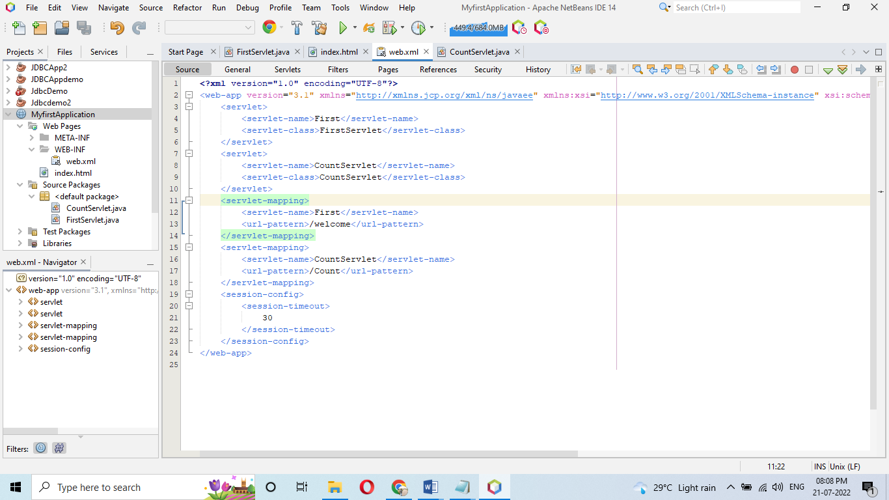

2. LINK THE SERVLET WITH THE INDEX.HTML PAGE

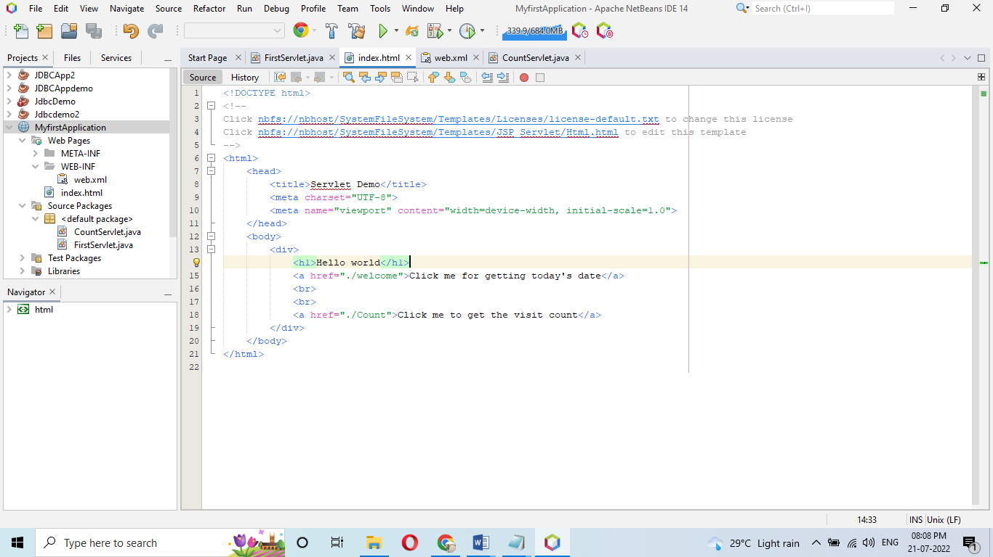

3. CREATE FIRST SERVLET.JAVA PAGE

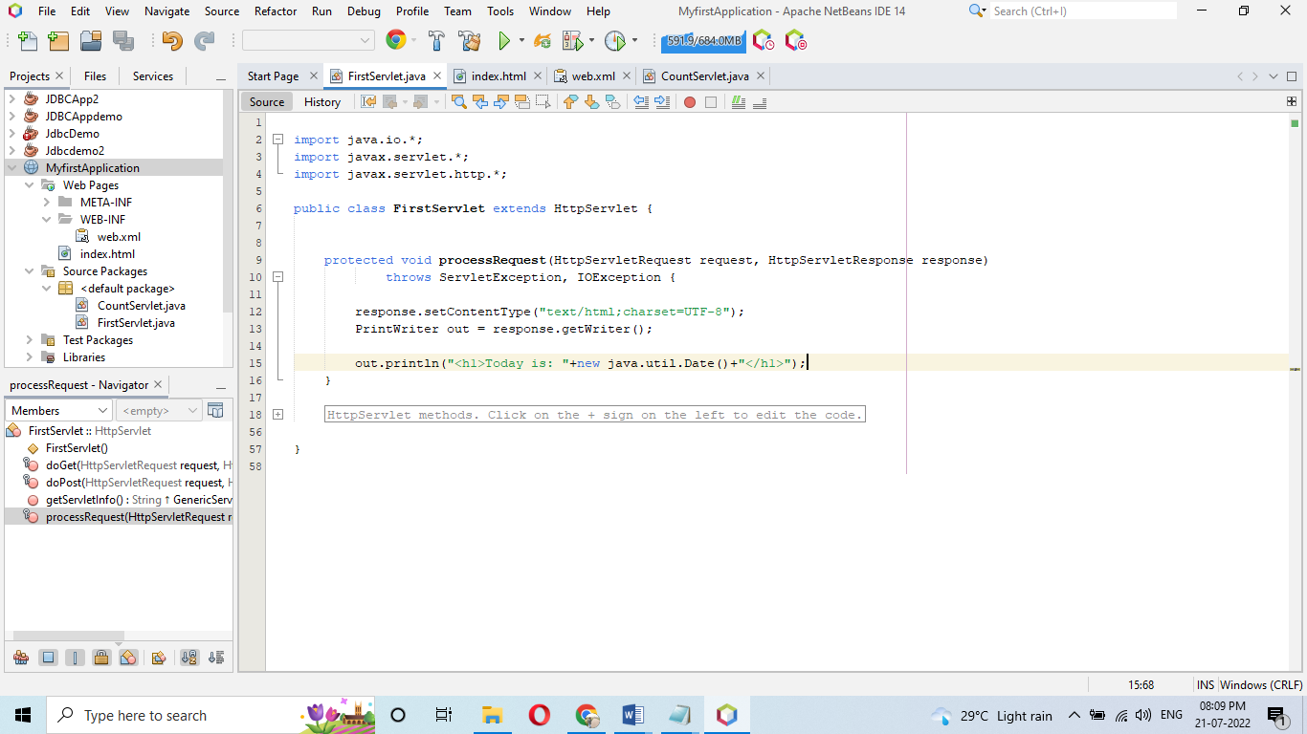

4. CREATE COUNT PAGESERVLET.JAVA PAGE

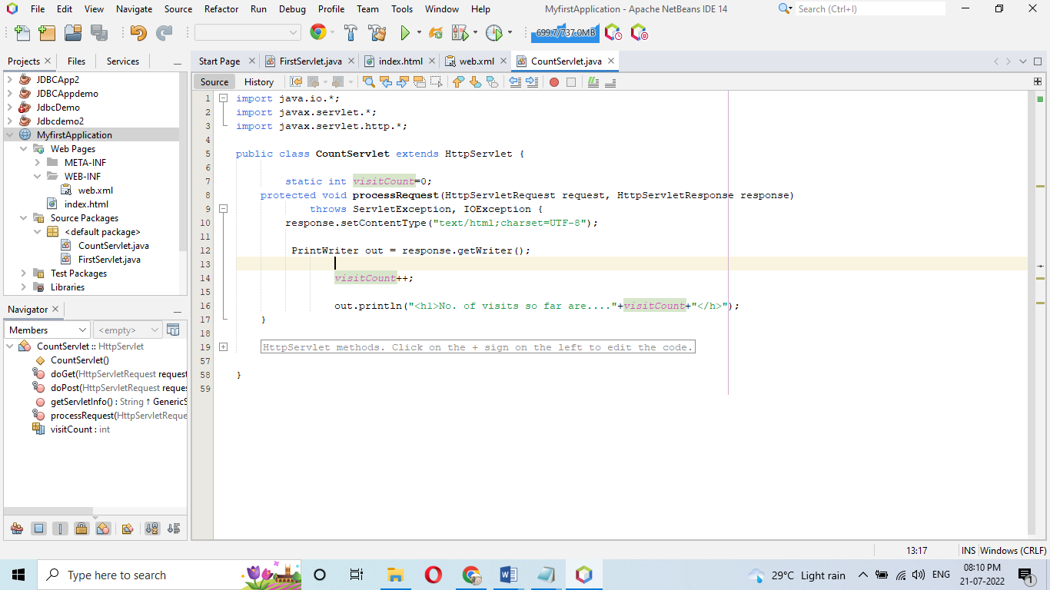

5. MAPPING BOTH THE PAGES WITH WEB.XML:

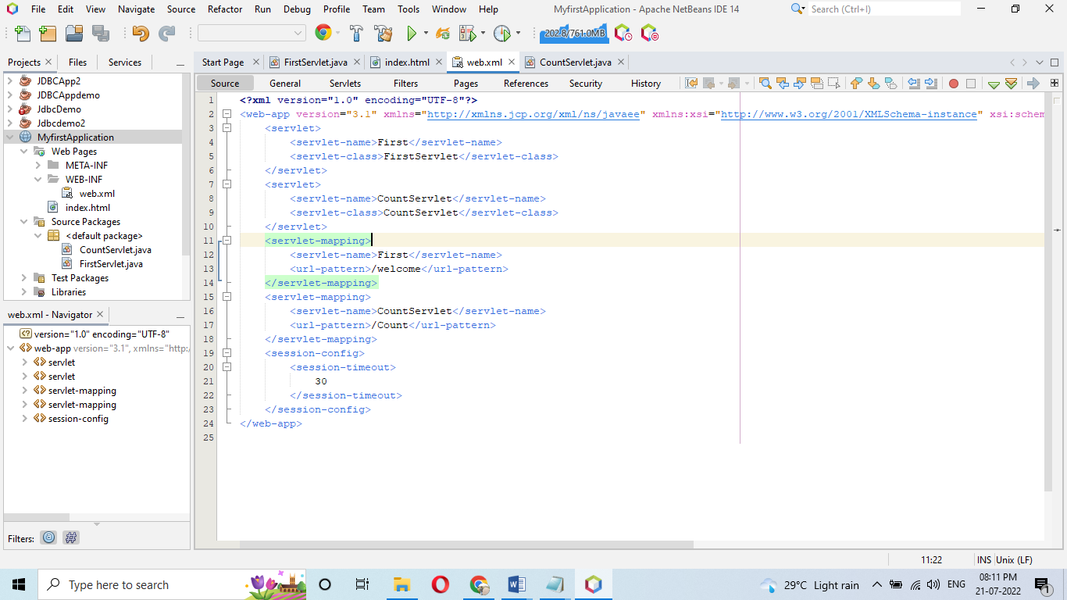

OUTPUT WINDOW:

